THE INFLUENCE OF THE LEVEL OF KNOWLEDGE OF THE IMPORTANCE OF DIGITAL BUSINESS ON THE INTEREST OF PROSPECTIVE STUDENTS TO ENROLL IN THE DIGITAL BUSINESS STUDY PROGRAM OF WIRARAJA UNIVERSITY

Moh. Baqir Ainun, Ahmad Ghufrony, Fathorrahman, Stevan Ariputra Harmanto, Diah Anggreini Pitaloka
Faculty of Economics and Business, Universitas Wiraraja, Sumenep
baqirainun@wiraraja.ac.id, ghufrony@wiraraja.ac.id, fathorrahman@wiraraja.ac.id, stevan@wiraraja.ac.id, diahaggraini@wiraraja.ac.id

ABSTRACT
The purpose of this study is to determine the influence of the Level of Knowledge of the Importance of Digital Business on the Interest of Prospective Students enrolling in the Digital Business Study Program of Wiraraja University. In addition, this study also tested the moderation effect of Knowledge Level on the Digital Business Study Program of Wiraraja University. This study used questionnaires distributed to Menenga Atas School Students and equivalent in Sumenep Regency. The number of respondents was 257 out of 7 high schools in Sumenep. Data analysis was performed using SmartPLS Structural Equation Modelling (SEM) at a significant rate of 5%. The results showed that the level of knowledge of the importance of digital business has a significant positive effect on the interest of prospective students to enroll in the Digital Business study program of Wiraraja University. In addition, the Level of Knowledge about the Digital Business Study Program of Wiraraja University is also proven to have a moderation effect. The first implication of this research is that universities, especially Wiraraja University, must socialize the importance of digital business in the digital era to prospective new students and make it a reason to invite prospective new students to enroll in the Digital Business study program. The second implication is that universities, especially Wiraraja University, must promote that Wiraraja University has opened a Digital Business study program that promises competent graduates in Digital Business.
Keywords: level of knowledge, interests, prospective students, digital business

This article is licensed under CC BY-SA 4.0

INTRODUCTION
The development of the world of education has advanced in such a way. Various learning systems up to majors in universities have developed according to current needs (Miranda et al., 2021). One tangible form of development in the world of Education in an effort to prepare resources in accordance with current needs is the opening of the Digital Business study program. The Digital Business study program is a new study program in the world of Indonesian Higher Education (Sutanto, 2017).
The Digital Business study program is a study program formed to prepare human resources in the field of mastering digital start-ups and marketplaces that are needed in today's digital era. The digital business study program is a study program that has the strength of business learning using digital technology (Attaran, 2004). Digital Business is a combination of the fields of management, business, accounting, information systems, to informatics engineering (Vasarhelyi & Greenstein, 2003). The digital business department itself is a family of applied sciences that apply how the process of designing a digital business (Soliman & Youssef, 2001). Therefore, it is possible that experts in the field of digital business are also needed at various management levels in various industries ranging from finance to banking (Rahmawati et al., 2022).
The first campus to open a Digital Business study program is Padjadjaran University in the 2018/2019 academic year. Although relatively new, there are quite a lot of enthusiasts from this study program, this is indicated by the number of enthusiasts for this study program recorded at 1,257 students with a capacity of only 28 people in 2022 on the SBMPTN (www.unpad.ac.id) route. The large number of enthusiasts for this study program eventually attracts other campuses to open similar study programs in order to accommodate public interest in having competence in the field of digital business (Roueche & Baker III, 1987).
Wiraraja University is one of the campuses that participated in opening the Digital Business study program in the 2021/2022 academic year. This shows that Wiraraja University is also committed to participating in preparing human resources who have expertise in the field of digital business. The geographical location of Wiraraja University in Sumenep Madura Regency, makes Wiraraja University the first and only campus to open this study program in Sumenep Regency, even on the island of Madura. This shows that Wiraraja University is trying to open new opportunities for the people of Madura, especially Sumenep Regency to have competence and expertise in the field of digital business and be ready to face the development of the world of work in the digital era.
Based on developments in the digital era and the promising prospects of the Digital Business study program, the opening of the Digital Business study program at Wiraraja University is very promising in the number of new student admissions at Wiraraja University itself. However, the data obtained from UPT. The admission of new students of Wiraraja University, the number of new students and the number of enthusiasts for the Digital Business study program are still very minimal. Although there is an increase in the number of students between the 2021/2022 academic year and the 2022/2023 academic year, the increase is still not significant.
The number of applicants for the Digital Business study program at Wiraraja University that has been realized is still not in line with the expectations of the Institution. In fact, when viewed from the job prospects of graduates, digital developments, the geographical location of the campus, and the existence of the campus which is the only campus that opens a Digital Business study program in Sumenep Madura, then the Digital Business study program of Wiraraja University should be a study program that is in demand by the community, which in this case is prospective students.
The mismatch between expectations and realization that occurs indicates that there are factors that need to be considered by Wiraraja University. One of these factors is the knowledge of the Madurese people, especially Sumenep Regency about the importance of Digital Business. Jerni et al (2021), stated that the level of knowledge is one of the factors that can have an impact on interest. Some cases show that a person's interest in something will be low if the level of knowledge of something is also low (Jerni et al., 2021; Marlius & Ananda, 2020; Mustika et al., 2019). This shows the possibility that public interest (prospective students) to enroll in the Digital Business Study program is low because the level of knowledge about the importance of digital business is still low. Therefore, the author feels the need to prove scientifically about the Influence of the Level of Knowledge of the Importance of Digital Business on the Interest of Prospective Students enrolling in the Digital Business Study Program of Wiraraja University.

METHOD
This research is quantitative research. The type of data used in this study is primary data (Arikunto, 2006). Data collection techniques are carried out by disseminating kuesioner to the respondents. The number of respondents who participated in the study was 257 from 7 high schools in Sumenep Regency. The data analysis technique in this study uses the help of Structural Equation Modelling (SEM) SmartPLS.

RESULTS AND DISCUSSION
This research uses the help of SEM SmartPLS to determine the influence of Knowledge of the Importance of Digital Business on Study Interest in the Digital Business Study Program of Wiraraja University. This study was also conducted to examine the effect of moderation of Knowledge about the Digital Business study program at Wiraraja University on the influence of knowledge of the importance of digital business on the Interest of Prospective Students to Enroll in the Digital Business Study Program at Wiraraja University.
Figure 1 shows the output results of the validity convergent test where all indicators have a loading factor value above 0.5. In addition, the results of the Average Variance Extracted (AVE) test obtained a value of all constructs >0.5 indicating that the indicator is able to explain the factor. The reliability test shows that all constructs get a composite reliability value of >0.6 which means that the constructs described are reliable (Table 2).
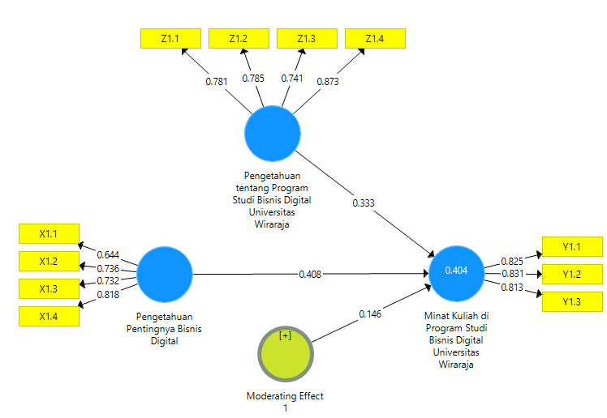
Figure 1. Factor loading model fit analysis

Table 2. Average Variance Extracted (AVE) and Composite Reliability
 | Composite Reliability | Average Variance Extracted (AVE)
Study Interest in Digital Business Study Program, Wiraraja University (Y1) | 0.863 | 0.677
Moderating Effect 1 | 1.000 | 1.000
Knowledge of the Importance of Digital Business (X1) | 0.824 | 0.540
Knowledge of Digital Business Study Program, Universitas Wiraraja (Z1) | 0.874 | 0.635

Figure 2 shows that X1 against Y1 has a T value of 4.595 (>1.96) so that X1 has an effect on Y1. Z1 to Y1 has a T value of 3.134 (>1.96) so Z1 has an effect on Y1. Moderating Effect 1 has a T value of 2.626 (>1.96) so it can be said that Z1 moderates the effect of X1 on Y1. Based on these results, it can be known that H1 and H2 in this study were confirmed.
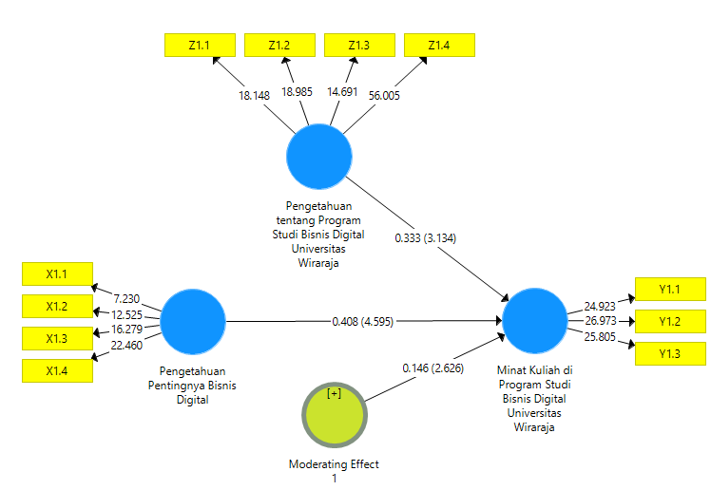
Figure 2. T value model fit analysis

DISCUSSION
Based on the results of the study, it can be seen that Knowledge of the Importance of Digital Business (X1) has a positive and significant effect on the Interest of Prospective Students to Enroll in the Digital Business Study Program of Wiraraja University (Y). The higher the respondent's knowledge about the importance of digital business, the higher their interest in enrolling in the Digital Business Study Program of Wiraraja University. Conversely, the lower a person's knowledge about the importance of digital business, the lower his interest in enrolling in the Digital Business Study Program of Wiraraja University. The results of this study are in line with the results of previous research conducted by Mustika et al (2019) and Anggraeni & Harnanik (2015).
The era of technology shows the magnitude of business opportunities using digital technology (Lyu & Liu, 2021). In addition, the success of business in the digital era also depends on the compatibility of business actors to utilize these technologies to support business processes (Prastyaningtyas & Arifin, 2019). Knowledge of the importance of having competence in the field of business science and digital science to be successful in the field of digital business, will increase their interest in learning more deeply about digital business, such as by studying it at a College majoring in Digital Business (Sudirman & Usman E, 2018).
The results of the study also showed that the hypothesis of both studies was confirmed. This shows that Knowledge of Digital Business Study Program of Universitas Wiraraja moderates the influence of Knowledge of the Importance of Digital Business on Study Interest in Digital Business Study Program of Universitas Wiraraja.
Knowledge about the importance of digital business certainly creates the interest of female students to study in the digital business study program of Wiraraja University. The creation of this interest is strengthened by students' knowledge about the Digital Business Study Program of Wiraraja University. The moderation variable in this study can be categorized as quasi-moderation. This is because, the variables of Knowledge about the Digital Business Study Program of Wiraraja University and Moderating effect 1 both have a significant influence on Study Interest in the Digital Business Study Program of Wiraraja University.

CONCLUSION
Based on the results of research and discussion, it can be seen that Knowledge of the Importance of Digital Business has a positive and significant effect on the Interest of Prospective Students to Enroll in the Digital Business Study Program of Wiraraja University. In addition, Knowledge of Digital Business Study Program of Universitas Wiraraja moderates the influence of Knowledge of the Importance of Digital Business on Study Interest in Digital Business Study Program of Universitas Wiraraja.
The first implication of this research is that universities, especially Wiraraja University, must socialize the importance of digital business in the digital era to prospective new students and make it a reason to invite prospective new students to enroll in the Digital Business study program. The second implication is that universities, especially Wiraraja University, must promote that Wiraraja University has opened a Digital Business study program that promises competent graduates in Digital Business.
This study has a limitation that is the lack of response from research respondents, so future research can overcome this limitation.
Acknowledgment
Acknowledgments are conveyed to the Institute for Research and Community Service of Wiraraja University for funding this research in accordance with the research contract Number: 010/SP2H/PEN-DI/LPPM/UNIJA/VII/2022.

REFERENCES
Anggraeni, B., & Harnanik. (2015). Pengaruh Pengetahuan Kewirausahaan Dan Lingkungan Keluarga Terhadap Minat Berwirausaha Siswa Kelas Xi Smk Islam Nusantara Comal Kabupaten Pemalang. Jurnal Pendidikan Ekonomi Dinamika Pendidikan, X(1), 42–52.
Arikunto, S. (2006). Prosedur Penelitian. Rineka Cipta.
Attaran, M. (2004). Exploring the relationship between information technology and business process reengineering. Information & Management, 41(5), 585–596.
Jerni, Tahir, T., Hasan, M., Rahmatullah, & Said, I. (2021). Pengaruh Literasi Ekonomi Dan Literasi Digital Terhadap Minat Berwirausaha Mahasiswa. Indonesian Journal of Economics, Entrepreneurship and Innovation, 2(1), 18–27. https://doi.org/10.31960/ijoeei.v2i1.1038
Lyu, W., & Liu, J. (2021). Artificial Intelligence and emerging digital technologies in the energy sector. Applied Energy, 303, 117615.
Marlius, D., & Ananda, F. (2020). Pengaruh Kualitas Pelayanan Website Akademik Terhadap Minat Kuliah Di Akbp Padang. Jurnal Pundi, 3(3), 191. https://doi.org/10.31575/jp.v3i3.190
Miranda, J., Navarrete, C., Noguez, J., Molina-Espinosa, J.-M., Ramírez-Montoya, M.-S., Navarro-Tuch, S. A., Bustamante-Bello, M.-R., Rosas-Fernández, J.-B., & Molina, A. (2021). The core components of education 4.0 in higher education: Three case studies in engineering education. Computers & Electrical Engineering, 93, 107278.
Mustika, A., Desafitri R.B, L., & Irfal. (2019). Persepsi Siswa Terhadap Minat Kuliah Di Perguruan Tinggi Pariwisata. Jurnal Penelitian Manajemen, 1(April), 68–77.
Prastyaningtyas, E. W., & Arifin, Z. (2019). Pentingnya Pendidikan Kewirausahaan pada Mahasiswa dengan Memanfaatkan Teknologi Digital Sebagai Upaya Menghadapi Revolusi 4.0. Proceedings of The ICECRS, 2(1), 281–285. https://doi.org/10.21070/picecrs.v2i1.2382
Rahmawati, L., Badri, R. E., & Ariza, M. (2022). Analisis Swot Dan Identifikasi Faktor-Faktor Yang Membuat Siswa Tertarik Mendaftar Ke Program Studi Bisnis Digital. JURNAL SOSIAL EKONOMI DAN HUMANIORA, 8(2), 282–291.
Roueche, J. E., & Baker III, G. A. (1987). Access & Excellence: The Open-Door College. ERIC.
Soliman, F., & Youssef, M. (2001). The impact of some recent developments in e‐business on the management of next generation manufacturing. International Journal of Operations & Production Management.
Sudirman, & Usman E. (2018). The effect of budget participation on budgetary slack. Russian Journal of Agricultural and Socio-Economic Sciences, 7(79), 150–157.
Sutanto, E. M. (2017). The influence of organizational learning capability and organizational creativity on organizational innovation of Universities in East Java, Indonesia. Asia Pacific Management Review, 22(3), 128–135.
Vasarhelyi, M., & Greenstein, M. (2003). Underlying principles of the electronization of business: A research agenda. International Journal of Accounting Information Systems, 4(1), 1–25.

