Analysis of Factors Influencing to Hydroponic Purchasing Decision in Pangkalpinang: A Particial Least Squares Structural
Equation Modelling (PLS-SEM) Approach

Dewa Ayu Gianina¹, Muhammad Yamin², Selly Oktarina³
Master’s Program in Agribusiness, Faculty of Agriculture, Universitas Sriwijaya, Palembang, Indonesia
dewagianina@gmail.com¹, yamin@unsri.ac.id², sellyoktarina@unsri.ac.id³

ABSTRACT
The rapid growth of urbanization and increased health awareness among consumers in Pangkalpinang, Bangka Belitung, have increased interest in hydroponic vegetables. This study aims to analyze the factors influencing consumer purchasing decisions for hydroponic vegetables in Pangkalpinang. Using a quantitative approach, data were collected from 170 respondents through surveys, focusing socioeconomic, psychological, and marketing factors. The study employed Particial Least Squares Structural Equation Modelling (PLS-SEM) to identify significant predictors of purchasing decisions. The analysis of direct effects reveals that perception, attitude, product, and income significantly influence purchasing decisions, while motivation and price do not have a significant impact. Indirect effects analysis indicates that price influences purchasing decisions through perception and attitude, although it does not do so through motivation. These findings underscore the crucial roles of product quality and consumer perception, with price exerting an indirect impact on purchasing decisions. This research offers valuable insights for hydroponic entrepreneurs, emphasizing the importance of enhancing product quality and consumer perception to improve marketing strategies.
Keywords: Consumer Behavior, Hydroponic, PLS-SEM, Purchasing Decision

This article is licensed under CC BY-SA 4.0

INTRODUCTION
The rapid growth of urban populations has driven changes in consumption patterns in Indonesia, where urban residents are increasingly drawn to healthy, high-quality, and environmentally friendly products, such as hydroponic vegetables. Hydroponics, a modern agricultural method that utilizes nutrient-rich water instead of soil, has proven to produce cleaner, safer products free from pesticides (Khairiyakh et al., 2022). This type of farming offers a viable solution for urban areas with limited land, while also enhancing food security (Shi et al., 2022).
According to Kotler and Keller (2022), consumer behavior is influenced by various factors, including psychology, social, cultural, and economic elements, all of which directly shape purchasing decisions. Consumers motivated by the desire to lead healthier lifestyles tend to choose hydroponic products due to their perceived higher quality and chemical-free nature. Motivation and perception, especially concerning health and environmental benefits, play a crucial role in purchasing decisions (Soler-Anguiano et al., 2023).
In Pangkalpinang, hydroponic businesses have seen significant growth, supported by government programs involving Women's Farming Groups (KWT) and other entrepreneurs. As of 2023, there were 58 hydroponic businesses spread across all districts, with key products including spinach, pakcoy, mustard greens, and lettuce (Pangkalpinang Food Agency, 2023). These hydroponic vegetables are known for their superior quality and freshness compared to conventional vegetables, making them the top choice for urban consumers who prioritize health (Khairiyakh et al., 2022).
In addition to health factors, price and product availability are also major considerations for consumers when purchasing hydroponic vegetables. Research by Widodo et al., (2022) in Kediri found that price, product quality, and promotion significantly influenced the purchase of hydroponic vegetables. Furthermore, psychological factors such as perceptions of health benefits and product freshness also play a significant role (Tania, 2022). Therefore, understanding how these factors interact is crucial for hydroponic entrepreneurs to adjust their marketing strategies effectively.
This study aims to analyze the factors influencing the purchase decisions of hydroponic vegetables in Pangkalpinang City, including psychological, socioeconomic, and marketing stimuli. It will also explore the extent to which consumer motivation and perception affect their attitudes toward hydroponic products, as Kotler and Keller (2022) explain that consumer purchasing decisions result from a complex interaction between internal and external factors that span various aspects of daily life. Consequently, this research is expected to provide comprehensive insights for hydroponic entrepreneurs to enhance their competitiveness in the local market (Papilaya, 2022; Widodo et al., 2022).

METHOD
This study uses a quantitative approach with a survey questionnaire to collect data from 170 hydroponic vegetable consumers in Pangkalpinang, Bangka Belitung. The research aims to understand the influence of marketing stimuli, socioeconomic, and psychological factors on purchase decisions. A simple random sampling technique was used to ensure equal opportunity for every individual in the population to participate. The collected data was analyzed using the Partial Least Square Structural Equation Modeling (PLS-SEM) method with Smart-PLS Ver 3.0 software. The evaluation involved bootstrapping to test the significance of the relationships between variables, with a T-statistic value (>1.96) and p-value at a 95% significance level. The PLS-SEM analysis included testing both the structural and measurement models.

RESULTS AND DISCUSSION
The evaluation of the measurement model on the outer model refers to testing the validity and reliability of a construct between latent variables and their indicators (Hair, 2022). In this measurement, two types of validity criteria are distinguished: Convergent Validity and Discriminant Validity. Convergent Validity includes the evaluation of individual item indicators, construct reliability, and the average variance extracted (AVE) from the latent variable. Discriminant Validity, on the other hand, assesses the correlation between constructs by comparing it with the square root of the variance.
Reliability consistency is assessed using the Reliability Coefficient rho A, Composite Reliability, and Cronbach's Alpha (Hair et al., 2021). The ideal reliability values for these measures are ≥ 0.70. This value is considered acceptable in exploratory research, while values between 0.80 and 0.90 are considered very good to excellent. Reliability values above 0.90 indicate excessive indicators, which may reduce construct validity (Hair et al., 2021). For convergent validity evaluation, an Average Variance Extracted (AVE) value above 0.50 is considered good for all indicators within each construct (Yew et al., 2022).

Table 1. Construct Reliability and Validity
Factors | Cronbach's Alpha | rho A | Composite Reliability | Average Variance Extracted (AVE) | Conclusion
Price | 0,739 | 0,743 | 0,852 | 0,659 | Reliable and Valid
Purchasing Decision | 0,859 | 0,859 | 0,914 | 0,780 | Reliable and Valid
Motivation | 0,713 | 0,724 | 0,838 | 0,633 | Reliable and Valid
Income | 0,748 | 0,747 | 0,856 | 0,665 | Reliable and Valid
Perception | 0,834 | 0,836 | 0,900 | 0,751 | Reliable and Valid
Product | 0,783 | 0,795 | 0,874 | 0,698 | Reliable and Valid
Attitude | 0,855 | 0,857 | 0,912 | 0,775 | Reliable and Valid

Discriminant validity is measured using the Heterotrait-Monotrait (HTMT) ratio, an alternative method recommended by experts to address limitations in Fornell-Lacker and Cross Loadings tests. An HTMT value above 0.90 indicates a lack of discriminant validity. For constructs that are more conceptually distinct, a more conservative threshold, such as 0.85, is recommended (Hair et al., 2021).

Table 2. Heterotrait-Monotrait (HTMT)
Factors | Price | Purchasing Decision | Motivation | Income | Perception | Product
Price
Purchasing Decision | 0,531
Motivation | 0,616 | 0,592
Income | 0,382 | 0,715 | 0,447
Perception | 0,503 | 0,587 | 0,534 | 0,379
Product | 0,577 | 0,843 | 0,651 | 0,584 | 0,517
Attitude | 0,529 | 0,734 | 0,655 | 0,536 | 0,515 | 0,824

All values are below the 0.85–0.90 range. The HTMT compares the average correlation between different constructs with the correlation between indicators within the same construct. The HTMT values, being smaller than the set thresholds of 0.85 and 0.90, are met by the field data. This confirms that no construct exceeds the ideal limits, making this test valid for confirming acceptable discriminant validity.
The structural model (inner model) in PLS SEM, also known as the internal model, shows the relationships and paths between constructs (Hair et al., 2021). The structural model is measured by the path coefficient, which represents the strength of the relationship between constructs. Once the direction of the path coefficients aligns with the hypothesized theory, resampling or bootstrapping is performed, followed by significance testing using the T-statistic ≥ 1.96 and P-value ≤ 0.05 (Hair, 2022).
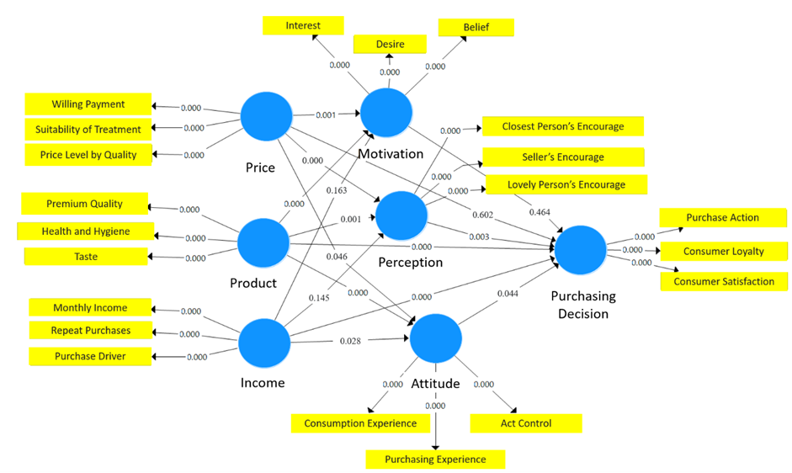
Figure 1. PLS SEM Path Model

Table 3. Factors Influencing Hydroponic Purchasing Decisions in Pangkalpinang
Relation of Factors |  |  |  | T Statistics | P Values | Conclusion
Direct Effect
Motivation → Purchasing Decision |  |  |  | 0,732 | 0,464 | Insignificant
Perception → Purchasing Decision |  |  |  | 3,008 | 0,003 | Significant
Attitude → Purchasing Decision |  |  |  | 2,021 | 0,044 | Significant
Price → Purchasing Decision |  |  |  | 0,522 | 0,602 | Insignificant
Product → Purchasing Decision |  |  |  | 4,637 | 0,000 | Significant
Income → Purchasing Decision |  |  |  | 4,150 | 0,000 | Significant
Indirect Effect
Price → Motivation → Purchasing Decision |  |  |  | 0,664 | 0,507 | Insignificant
Price → Perception → Purchasing Decision |  |  |  | 2,038 | 0,042 | Significant
Price → Attitude → Purchasing Decision |  |  |  | 1,339 | 0,181 | Insignificant
Product → Motivation → Purchasing Decision |  |  |  | 0,702 | 0,484 | Insignificant
Product → Perception → Purchasing Decision |  |  |  | 2,379 | 0,018 | Significant
Product → Attitude → Purchasing Decision |  |  |  | 1,950 | 0,052 | Insignificant
Income → Motivation → Purchasing Decision |  |  |  | 0,551 | 0,582 | Insignificant
Income → Perception → Purchasing Decision |  |  |  | 1,114 | 0,266 | Insignificant
Income → Attitude → Purchasing Decision |  |  |  | 1,462 | 0,144 | Insignificant

The T-statistic value is directly related to the P-value. A high T-statistic results in a small P-value, indicating a significant relationship. Conversely, a low T-statistic leads to a large P-value, indicating that the relationship is not significant. As shown in Table 3, the relationship between income and purchase decision has a T-statistic value of 4.150 (greater than 1.96), which means it is significant with a P-value of 0.000. The same applies to the factors of perception, attitude, and product.
On the other hand, the relationship between price and purchase decision has a T-statistic value of 0.522 (less than 1.96) and a P-value of 0.602, indicating that the relationship is not significant. The same result is found for the motivation factor. A similar explanation applies to the indirect relationship, where price significantly affects the purchase decision through intervening psychological variables, such as perception and attitude, but not through motivation. Meanwhile, marketing stimuli such as product and consumer socioeconomic factors which is income, do not influence purchase decisions through psychological intervening variables.
These results indicate that consumers tend to make purchasing decisions based on their perception and attitude toward product quality. Although price and motivation are not the main factors driving consumers to buy products in this context, psychological perceptions can change this dynamic. This demonstrates that perception has a significant mediating effect on consumer psychology in making decisions. The implications of these findings suggest that marketing strategies should focus on enhancing product quality and consumer perception to encourage purchasing decisions.

Tabel 4. Fit Summary
Variable | R² | SRMR | Conclusion
Purchasing Decision | 0,621 | 0,072 | Moderate and Model Fit
Motivation | 0,317 |  | Moderate
Perception | 0,239 |  | Moderate
Attitude | 0,498 |  | Moderate

The structural model strength test is conducted to evaluate how well the model explains endogenous variables. The main measures in this test include R Square (R²) and SRMR Estimated, which assess the extent to which the model can explain endogenous variables. The purchase decision variable has an R² value of 0.621, indicating that 62.1% of the variance in purchase decisions is explained by exogenous variables such as motivation, perception, attitude, price, product, and income. The SRMR value of 0.072 indicates that the model has a good overall fit, as SRMR values below 0.08 are typically considered indicators of adequate model fit in PLS-SEM.

CONCLUSION
This study was conducted in Pangkalpinang with a sample of 170 consumers. The results of the validity and reliability tests were found to be good, and the model strength test showed that the model is well aligned with the data. The factors that directly and significantly influence the decision to purchase hydroponic vegetables are perception, attitude, product, and income. Meanwhile, motivation and price do not have a direct effect. However, price has a significant impact on the indirect effect through intervening perception and attitude.
Based on the findings, it is recommended to focus on improving consumer perception in Pangkalpinang by highlighting the quality and benefits of hydroponic vegetables, while ensuring competitive pricing and high product quality. Targeted marketing strategies and further research could also help refine consumer engagement and expand understanding of purchasing behavior.

REFERENCES

Government Report on Food Security in Pangkalpinang (2023). Dinas Ketahanan Pangan Kota Pangkalpinang.
Hair Jr, J. F., Hult, G. T. M., Ringle, C. M., Sarstedt, M., Danks, N. P., & Ray, S. (2021). Partial least squares structural equation modeling (PLS-SEM) using R: A workbook. Springer Nature.
Hair, J.F., Hult, G.T.M., Ringle, C.M. and Sarstedt, M. (2022), A Primer on Partial Least Squares Structural Equation Modeling (PLS-SEM), Sage, Thousand Oaks, CA.
Khairiyakh, R., J. Sutrisno, R. Uchyani, Agustuno, E. Irawan, A. Nadifta, Ulfa dan I. Nurhidayati. 2022. Peningkatan Pengetahuan Masyarakat Perkotaan terhadap Urban Farming Melalui Pelatihan Budidaya Sistem Hidroponik di Kota Surakarta. In Seminar Nasional Pengabdian Masyarakat & CSR-Fakultas Pertanian UNS. Vol. 2 (1), No. 2018, h. 85–91.
Kotler, Philip, Keller, Kevin Lane, Chernev, A. 2022. Marketing Management 16Ed (16). Harlow: Pearson.
Papilaya, Jan E. 2022. Factors Affecting Hydroponic Vegetable Purchase Decisions. Internasioanal Jurnal on Orange Technology. Vol. 04, No. 2, h. 9–21.
Shi, C., C. Wu, J. Zhang, C. Zhang dan Q. Xiao. 2022. Impact of urban and rural food consumption on water demand in China from the perspective of water footprint. Sustainable Production and Consumption. Vol. 34, h. 148–162.
Soler-Anguiano, F. L., M. Zeelenberg dan R. Díaz-Loving. 2023. The Interaction of Product Attractiveness and Decision-Making Style on Consumer Purchase Intention: A Cultural Moderation Perspective. Journal of International Consumer Marketing. Vol. 35, No. 1, h. 19–29.
Tania, A. 2022. JU-ke (Jurnal Ketahanan Pangan). Jurnal Ketahan Pangan. Vol. 6, No. 2, h. 38–45.
Widodo, A., A. Daroini, S. Supriyono dan R. D. Mulyaningtiyas. 2022. Effect of Marketing Mix and Consumer Behavior on the Decision to Purchase Hydroponic Vegetables. International Journal of Social Sciences and Humanities. Vol. 6, No. 1, h. 30–41.
Yew, W. C., S. M. Kong, A. H. Awang dan G. R. Yi. 2022. Developing a Conceptual Model for the Causal Effects of Outdoor Play in Preschools Using PLS-SEM. Sustainability (Switzerland). Vol. 14, No. 6, h. 1–20.

